Taib Elbaroudi

Sue Sampson

Database Development and Use

Week 1

**GitHub Repository Setup**

**Local Directory Setup Instructions/ Clone Instructions:**

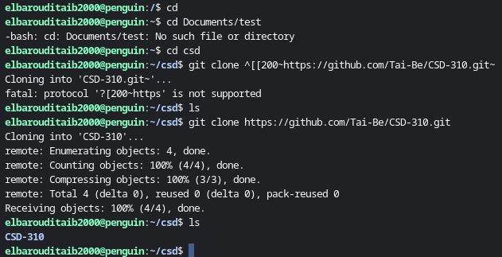

**Repository Setup Instructions:**

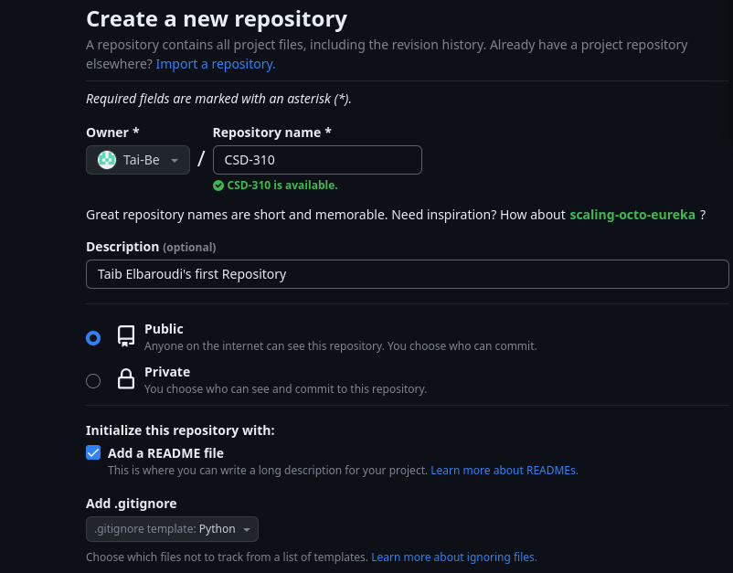

**Git Stage:**

